Ultrasonic Noise Characterization Test

**Group**: Mini-Project Group XX

**Date**: Sept 29th, 2021

**Tester(s)**: (who performed the test)

**Author**: Ryan Au

**Hardware version**: n/a ~~(not necessary for this lab, but for later)~~

**Software version**: n/a ~~(not necessary for this lab, but for later)~~

**Goal**: Determine the noise or precision of the Ultrasonic Sensor

Table of Contents

1.0 Purpose of Test 1

2.0 Test Objectives 1

3.0 Test Procedure 1

4.0 Expected Results 1

5.0 Format of Output Required 2

6.0 Test Report 2

7.0 Conclusions 2

7.1 Further Action 2

7.2 Distribution of Work 2

# 1.0 Purpose of Test

It is necessary to determine the exact noise of the Ultrasonic sensor, whether every measurement collected by the sensor maintains a consistent value even while moving the sensor while facing a target. This test does not measure accuracy (the correct real world distance to a given target).

# 2.0 Test Objectives

The main objective is to determine the potential amount of noise in the performance of the Ultrasonic sensor. An ideal sensor would have very little noise, for example, if the sensor is 20 cm away from a target and maintains this physical distance even while moving, the sensor’s measurements would maintain the same value throughout movement. The measured distance can be inaccurate for this test (e.g. 19.5 cm, 21 cm) however maintaining this same measured value indicates an ideal amount of noise, which is none.

# 3.0 Test Procedure

The following test should be performed at least **3 times** to ensure valid results.   
(Refer to *lab2/README.md* for technical details on running code on the robot and on your computer)

1. Connect the Touch Sensor to port S1 and the Ultrasonic Sensor to port S2
   1. Ensure the Ultrasonic Sensor is firmly attached to the robot.
   2. The Touch Sensor may be held freely in one hand while you perform this test
   3. You may use either battery or wired connection to power the robot
2. Run the function **collect_continuous_us_data()** on the robot (**project/collect_us_sensor_data.py**)
   1. Place the robot along a surface that is parallel to another e.g., in a hallway or a box
   2. Press the attached Touch Sensor, then slide the robot along the wall
   3. At the end of the parallel surfaces, press the touch sensor again to stop saving data  
      (see figure below)   
      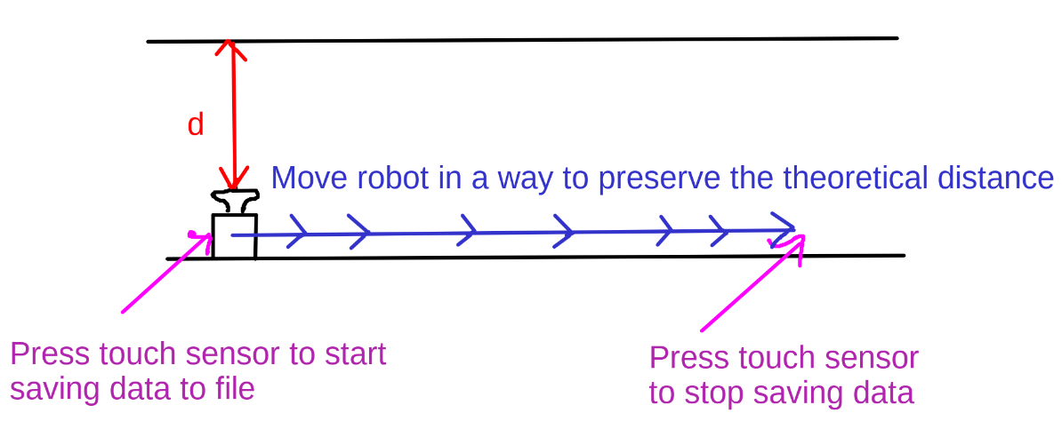
   4. Transfer the **us_sensor_cont.csv** file from the robot to your computer after one run (you can use NoMachine file transfer, transfer files using a USB drive, or email them to yourself if you robot has internet).
3. Make sure the csv file coming from **lab2/data_analysis** goes to the same folder **lab2/data_analysis** on your computer as well
   1. Run the **us_sensor_cont_vsiualization.py** file to plot this data.
   2. Save an image/screenshot of the plot that appears onscreen for your report
4. The graph that is generated plots the distance measured by the sensor over time
   1. This plot measure precision and not accuracy
   2. It should reveal **how much noise** is generated

# 4.0 Expected Results

The tests should reveal the potential amount of noise that the Ultrasonic sensor generates as it is moving while maintaining a fixed distance from a target. This noise factor can be expressed as a range of noise from the center value of data (if the noise varies from 45 cm to 49 cm noise is +/- 2cm).

# 5.0 Format of Output Required

Provide the auto-generated plots as part of the data collected from the each of the 3+ test executions. Also include the data points (from the csv file us_sensor_cont.csv) from the best test execution, in other words, the test execution that gleans the most information. Extra graphs can be generated using spreadsheets and included in test report, if relevant to conclusions.

# 6.0 Test Report

Write out the data collected and the analyzed output (Refer to *Section 5.0 Format of Output Required*)

# 7.0 Conclusions

What conclusions do you draw from these tests? Pass/Fail? Did you get your expected results?

Discuss these questions amongst your team to help you draw conclusions:

1. How much noise is generated from the 3 runs that you have performed?
2. Are there different ways to quantify this “amount of noise” using statistics?
3. If your US sensor is very noisy, then what does this mean for usefulness?
4. Any actions you must take in changing your design because of this?
5. Would you perform more than 3 runs to be sure of your noise measurement?
6. Does your procedure have any flaws that you would fix, but you could not fix due to time constraints?

## 7.1 Further Action

What you will do as a result of these tests?

## 7.2 Distribution of Work

Which departments will further action be assigned to? (Software, Project Management...)